COVID-19 ANALYTICS

Data description
A centralised repository of up-to-date and curated datasets on or related to the spread and characteristics of the novel coronavirus (SARS-CoV-2) and its associated illness, COVID-19. Globally, there are several efforts underway to gather this data, and we are working with partners to make this crucial data freely available and keep it up-to-date. Hosted on the AWS cloud, we have seeded our curated data lake with COVID-19 case tracking data from Johns Hopkins and The New York Times, hospital bed availability from Definitive Healthcare, and over 45,000 research articles about COVID-19 and related coronaviruses from the Allen Institute for AI.
Data is available here
https://registry.opendata.aws/aws-covid19-lake/

Scope of project

Create tables that contains:
- Dimensions
  - dim_date — calendar(date id(fulldate) , year, month, day )
  - dim_state — US states (state code and satefull name)
- Facts (daily, state-level)
  - fact_cases_state_daily — [cumulative cases/deaths & new cases/deaths]
  - fact_testing_state_daily – [cumulative tests,positivity & new tests, positivity]

Datasets (Bronze state)
S3 layout :

s3://<My_BUCKET>/covid/
bronze/ {nytimes|covid_tracking|static}/...
silver/ {cases_standardized | testing_standardized} /...
gold/ {dim_date | dim_state | fact_cases_state_daily | fact_testing_state_daily} /…
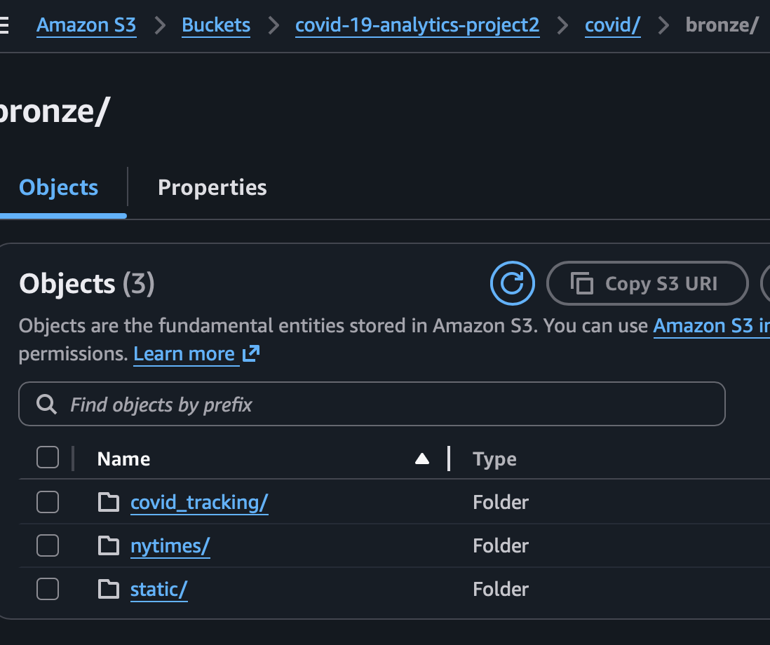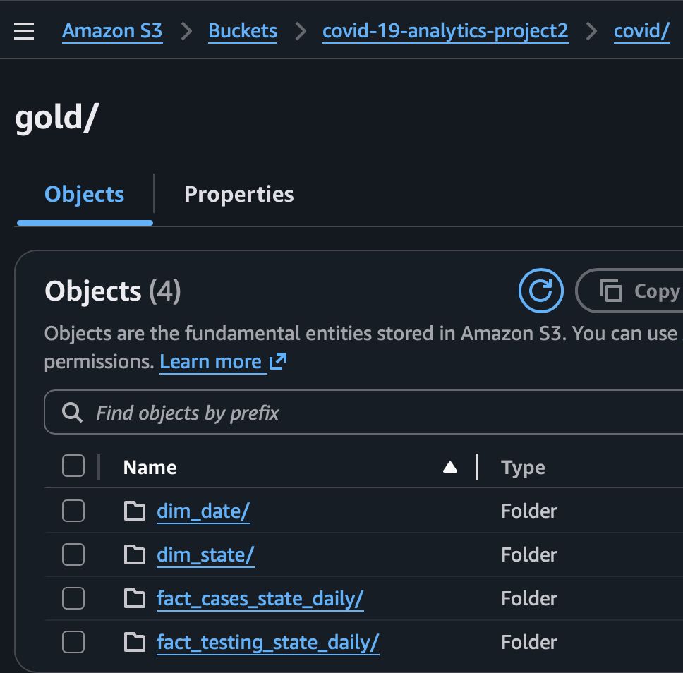
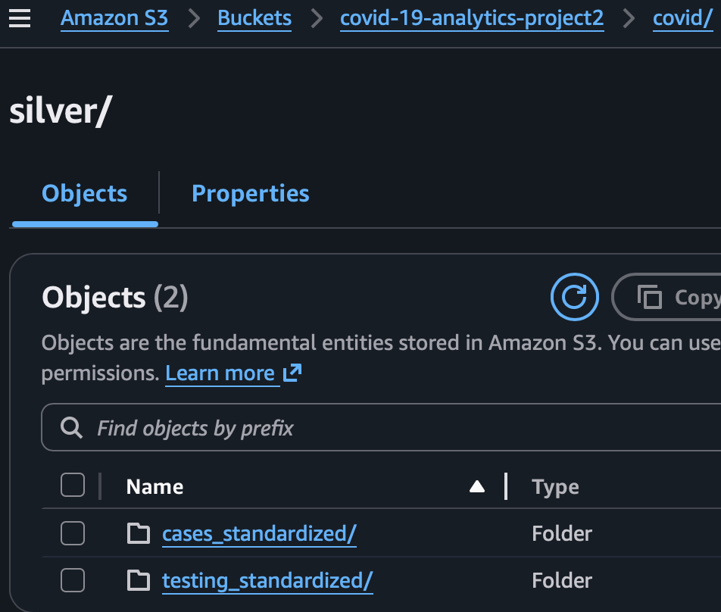
S3 Bucket contains raw csv
- nytimes/us_states.csv (or JHU state rollups) → cases/deaths
- covid_tracking/states_daily.csv → tests positive/negative/total
- static/states_abv.csv → map state name ↔ abbreviation

1) Bronze → Silver (standardize to Parquet)

1.1 What implemented
- Read CSVs from / bronze/
- Normalize and standarized:
  - full_date as DATE
  - state_code (2-char) and state_name (proper case) via states_abv.csv
  - Cast numerics to BIGINT/INT
- Write partitioned Parquet to silver/ with partitions: state_code, year, month, day
- Register Silver in Glue and validate in Athena

Glue spark for bronze etl job:
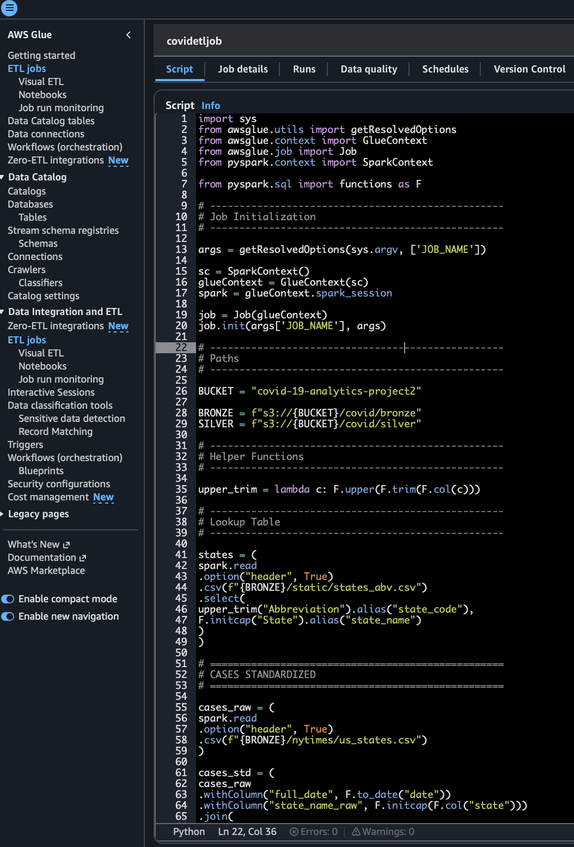
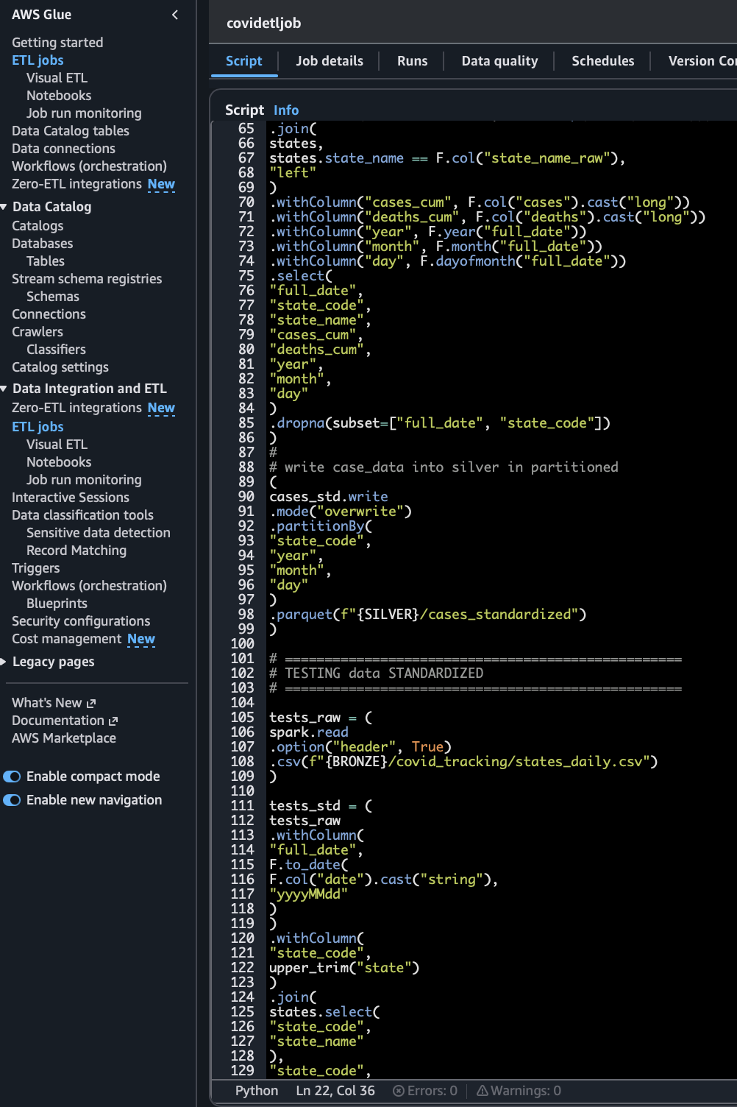
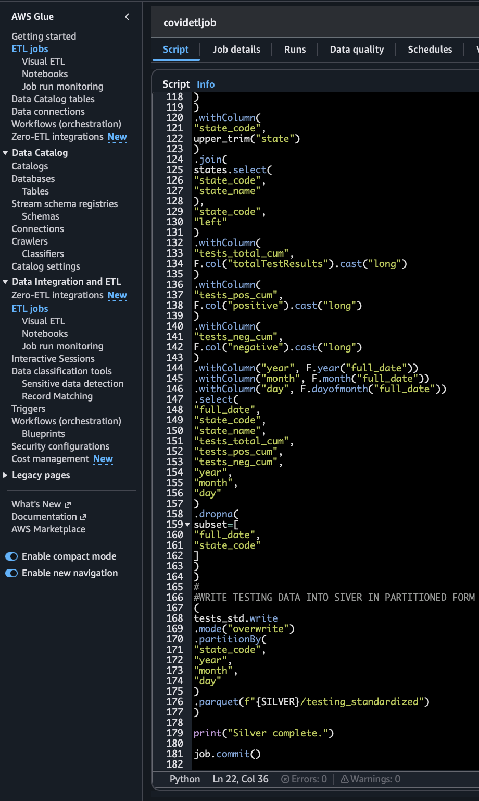

Glue/Athena register and validate Silver
CREATE EXTERNAL TABLE IF NOT EXISTS covid_silver_db.cases_standardized (
full_date date,
state_code string,
state_name string,
cases_cum bigint,
deaths_cum bigint,
year int,
month int,
day int
)
PARTITIONED BY (state_code string, year int, month int, day int)
STORED AS PARQUET
LOCATION 's3://YOUR_BUCKET/covid/silver/cases_standardized/';
MSCK REPAIR TABLE covid_silver_db.cases_standardized;

-- Testing
CREATE EXTERNAL TABLE IF NOT EXISTS covid_silver_db.testing_standardized (
full_date date,
state_code string,
state_name string,
tests_total_cum bigint,
tests_pos_cum bigint,
tests_neg_cum bigint,
year int, month int, day int
)
PARTITIONED BY (state_code string, year int, month int, day int)
STORED AS PARQUET
LOCATION 's3://YOUR_BUCKET/covid/silver/testing_standardized/';
MSCK REPAIR TABLE covid_silver_db.testing_standardized;

‘

-- ATHENA CHECK
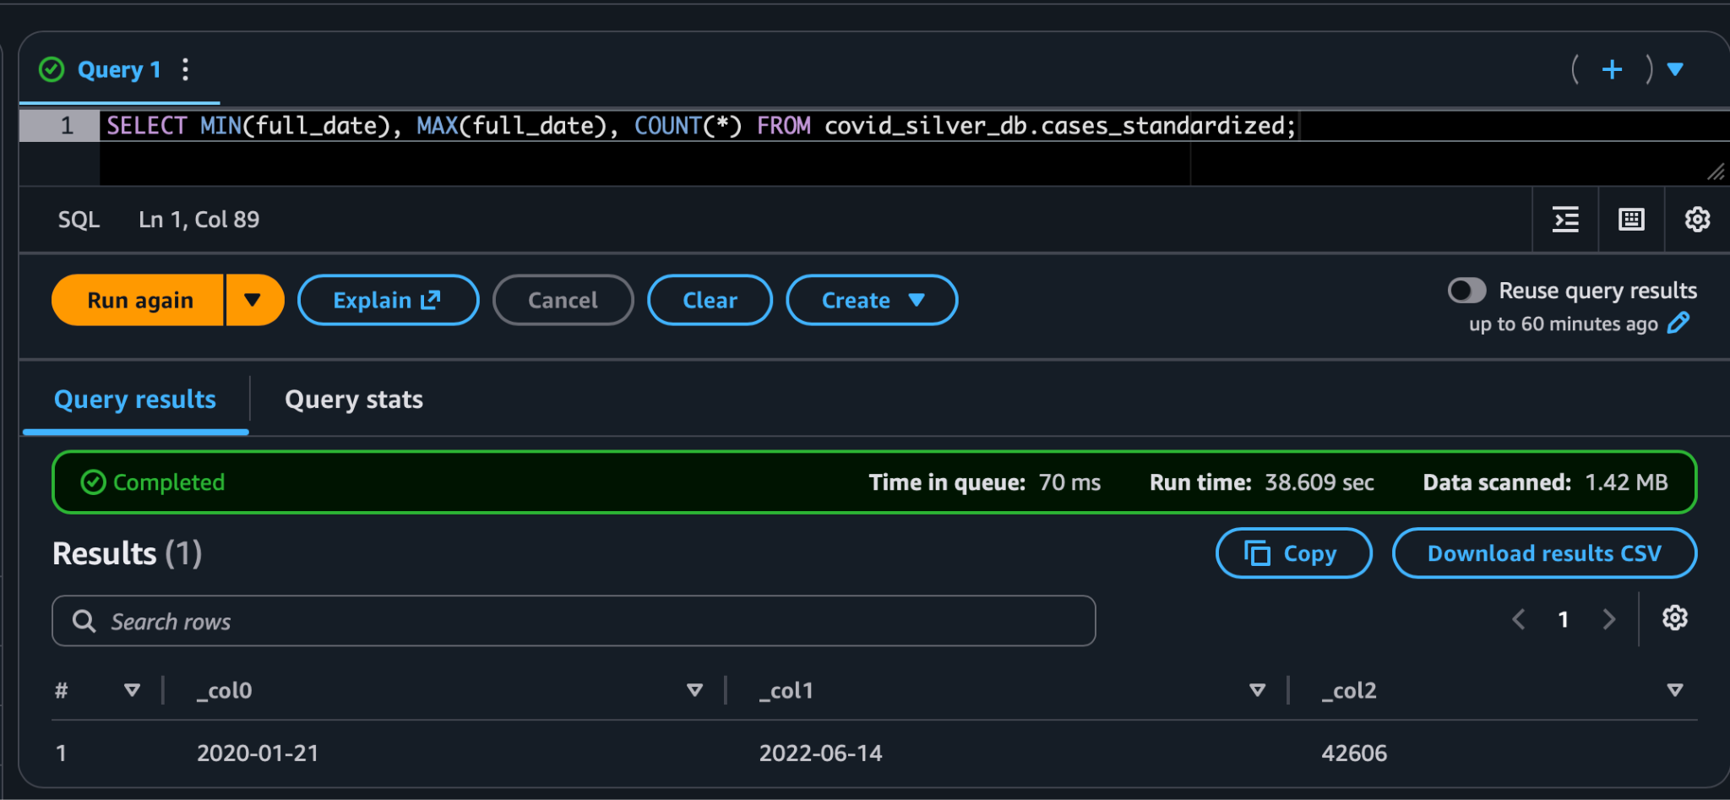
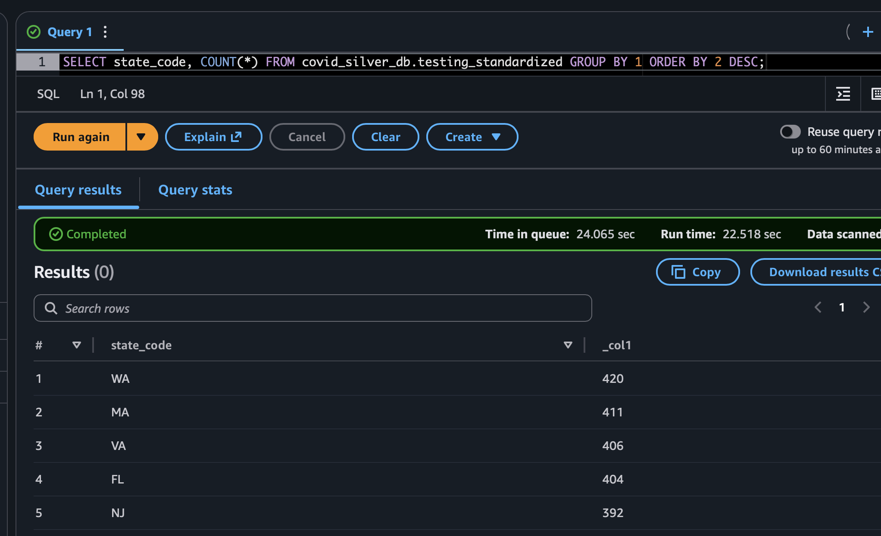
—--------------------------------------------------------------------------------------------------------------------

2) Silver → Gold (star schema)

2.1 Model (simple)
- dim_date: date_id (YYYYMMDD), full_date, year, month, day, dow, is_weekend
- dim_state: state_code (PK), state_name
- fact_cases_state_daily: date_id, state_code, cases_cum, deaths_cum, new_cases, new_deaths
- fact_testing_state_daily: date_id, state_code, tests_total_cum, tests_pos_cum, tests_neg_cum, new_tests, positivity_rate
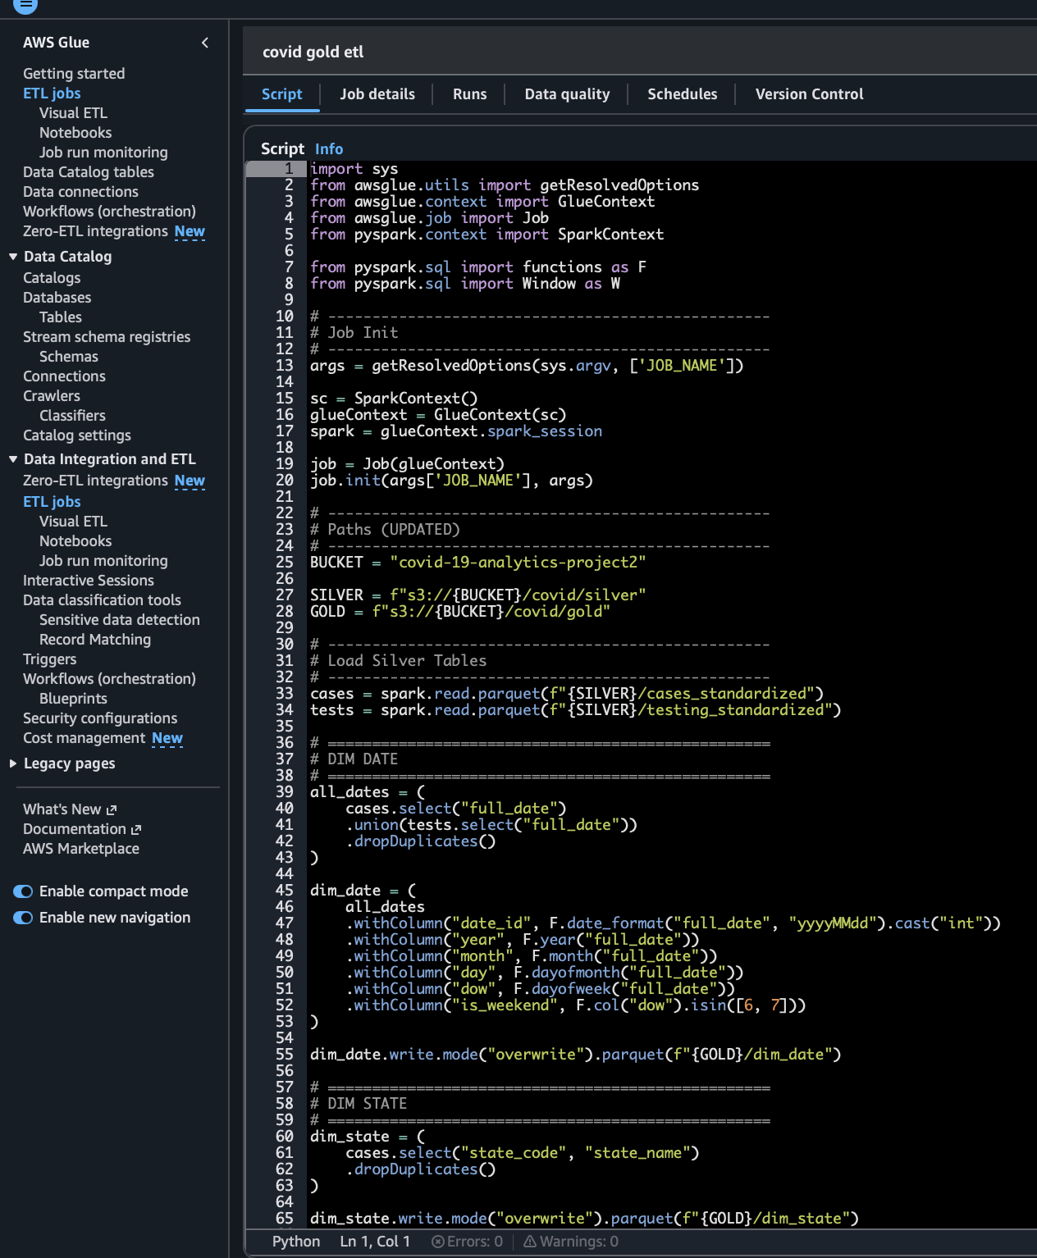
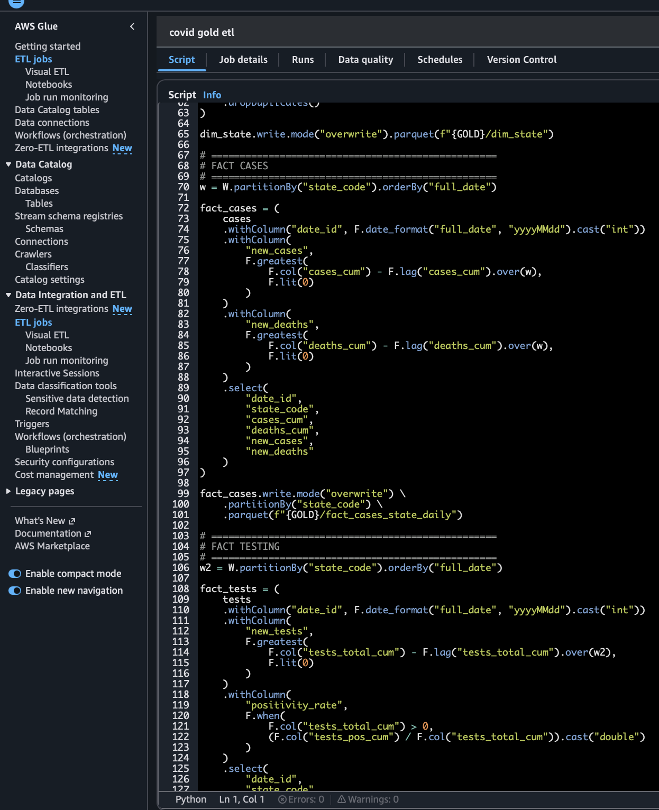

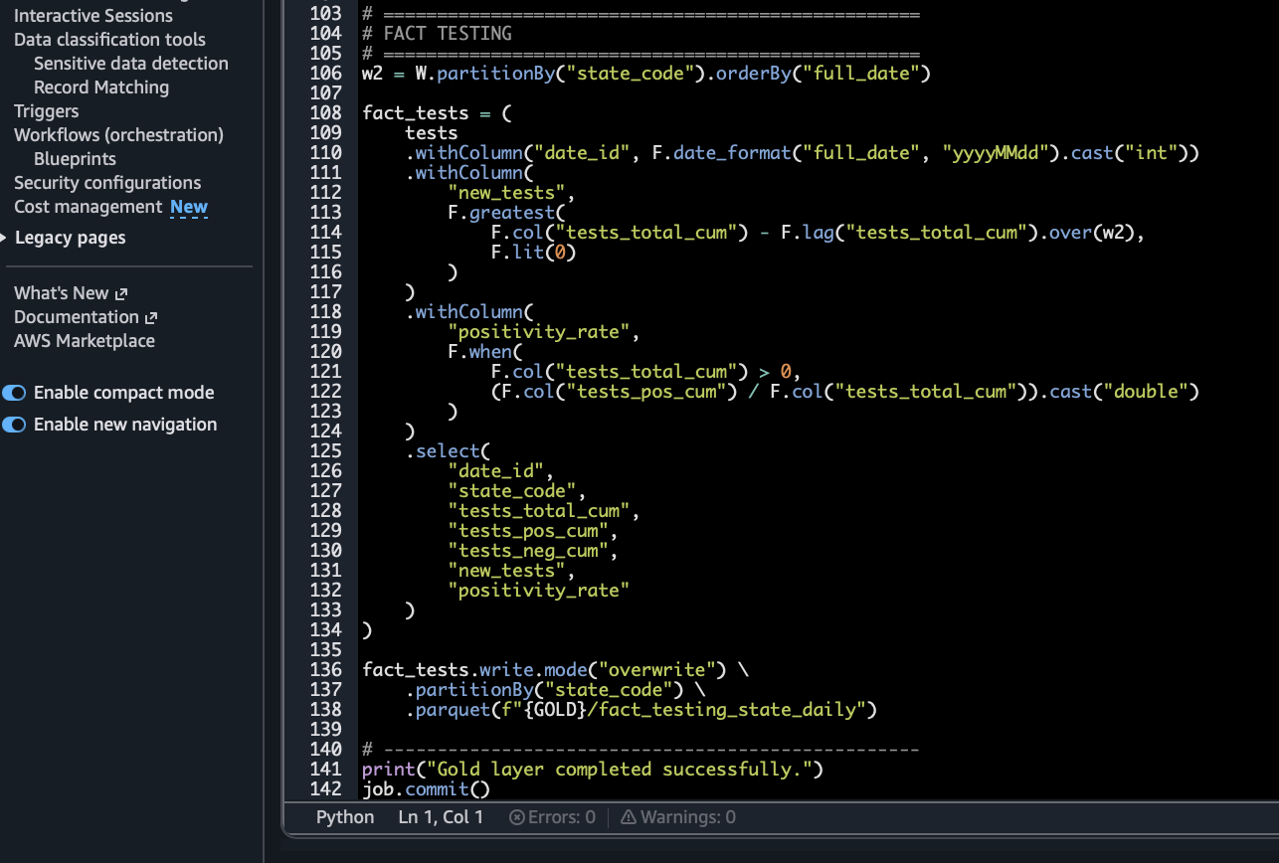
2.3 Glue/Athena — register Gold

CREATE DATABASE IF NOT EXISTS covid_gold_db;

CREATE EXTERNAL TABLE IF NOT EXISTS covid_gold_db.dim_date (
date_id int,
full_date date,
year int,
month int,
day int,
dow int,
is_weekend boolean
)
STORED AS PARQUET
LOCATION 's3://covid-19-analytics-project2/covid/gold/dim_date/';

CREATE EXTERNAL TABLE IF NOT EXISTS covid_gold_db.dim_state (
state_code string,
state_name string
)
STORED AS PARQUET
LOCATION 's3://covid-19-analytics-project2/covid/gold/dim_state/';

CREATE EXTERNAL TABLE IF NOT EXISTS covid_gold_db.fact_cases_state_daily (
date_id int,
state_code string,
cases_cum bigint,
deaths_cum bigint,
new_cases int,
new_deaths int
)
PARTITIONED BY (state_code string)
STORED AS PARQUET
LOCATION 's3://covid-19-analytics-project2/covid/gold/fact_cases_state_daily/';
MSCK REPAIR TABLE covid_gold_db.fact_cases_state_daily;

CREATE EXTERNAL TABLE IF NOT EXISTS covid_gold_db.fact_testing_state_daily (
date_id int,
state_code string,
tests_total_cum bigint,
tests_pos_cum bigint,
tests_neg_cum bigint,
new_tests int,
positivity_rate double
)
PARTITIONED BY (state_code string)
STORED AS PARQUET
LOCATION 's3://covid-19-analytics-project2/covid/gold/fact_testing_state_daily/';
MSCK REPAIR TABLE covid_gold_db.fact_testing_state_daily;

Check athena gold database:
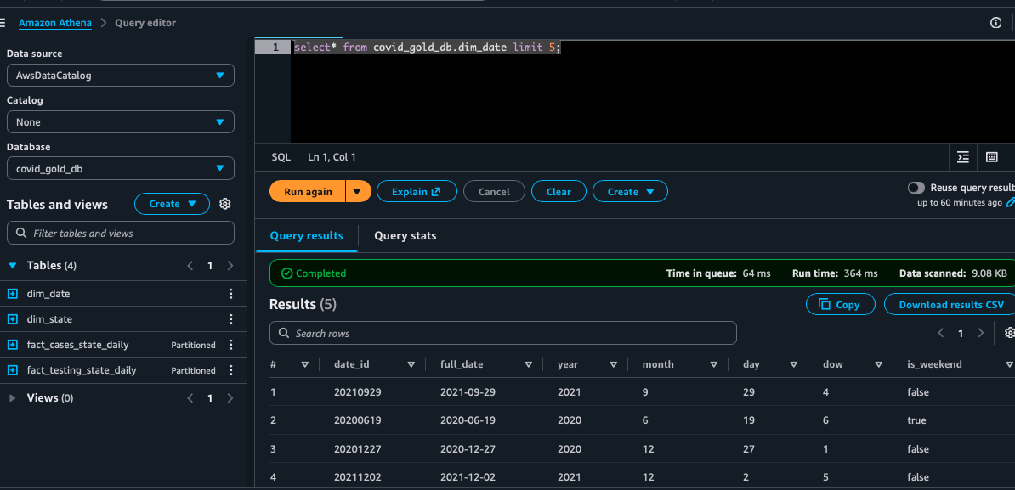

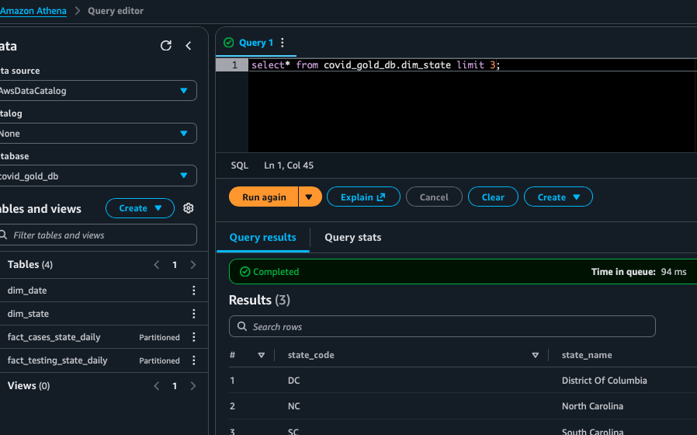
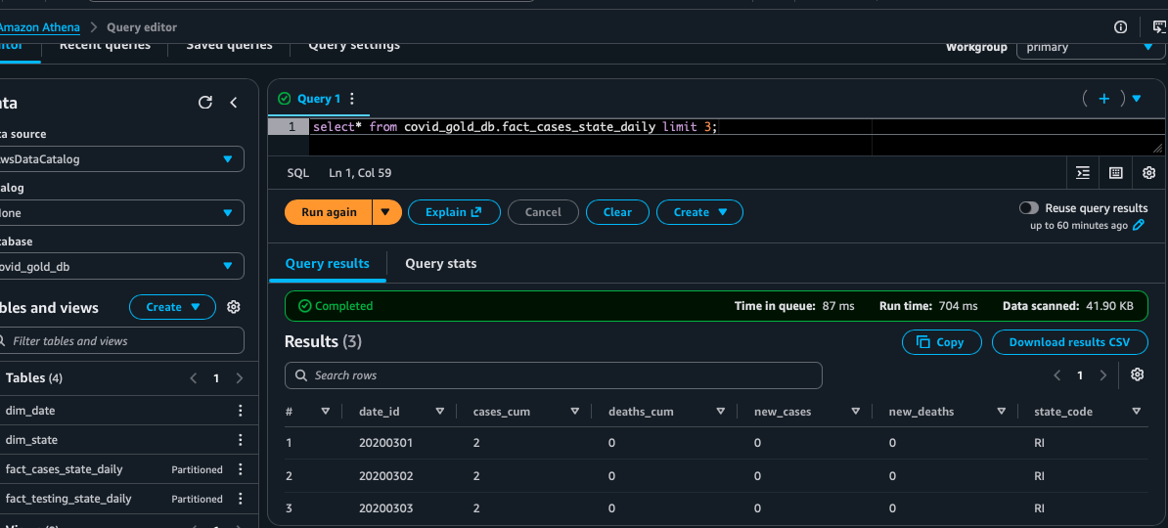
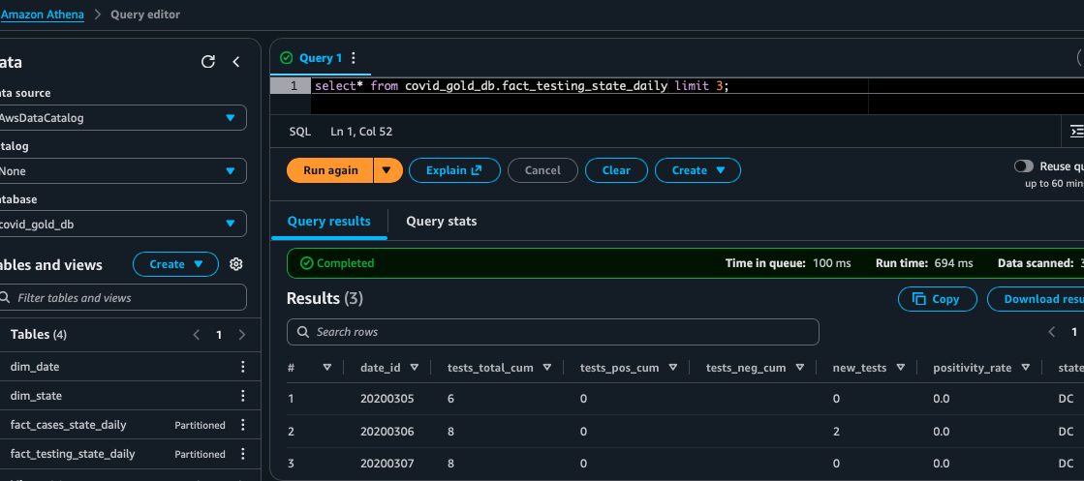

REDSHIFT
New namespace and workgroup
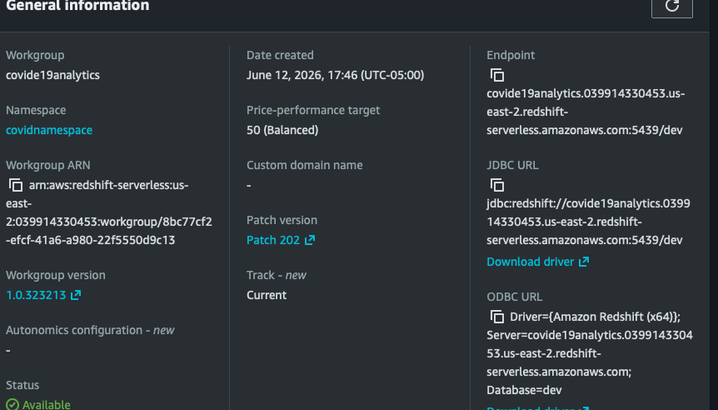
Query data
